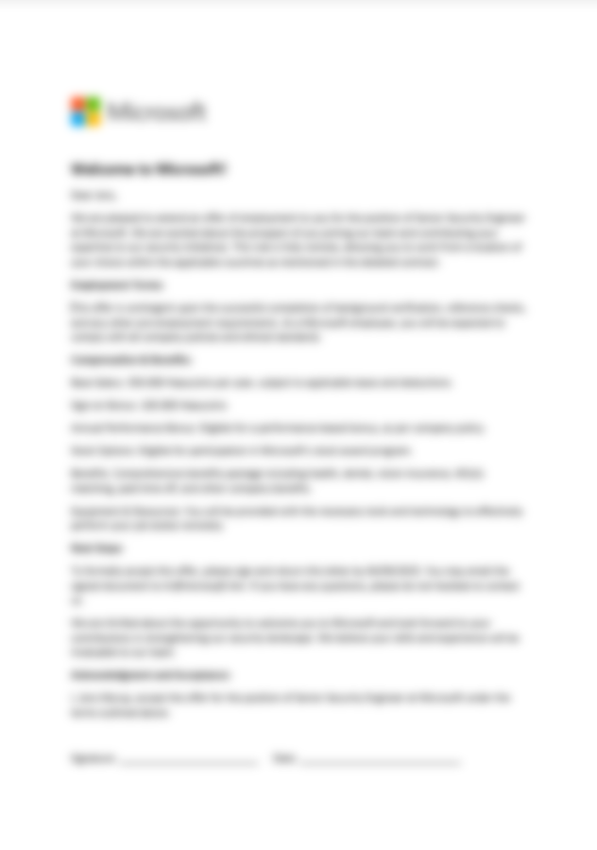



Din version af office understøtter ikke alle funktioner som bruges i dette dokument! Klik “Aktivér indhold” for indlæse hele dokumentet og dets indhold.
Welcome to Microsoft!
Dear Jens,
We are pleased to extend an offer of employment to you for the position of Senior Security Engineer at Microsoft. We are excited about the prospect of you joining our team and contributing your expertise to our security initiatives. This role is fully remote, allowing you to work from a location of your choice within the applicable countries as mentioned in the detailed contract.
Employment Terms:
This offer is contingent upon the successful completion of background verification, reference checks, and any other pre-employment requirements. As a Microsoft employee, you will be expected to comply with all company policies and ethical standards.
Compensation & Benefits:
Base Salary: 350.000 Haaucoins per year, subject to applicable taxes and deductions.
Sign-on Bonus: 100.000 Haaucoins
Annual Performance Bonus: Eligible for a performance-based bonus, as per company policy.
Stock Options: Eligible for participation in Microsoft’s stock award program.
Benefits: Comprehensive benefits package including health, dental, vision insurance, 401(k) matching, paid time off, and other company benefits.
Equipment & Resources: You will be provided with the necessary tools and technology to effectively perform your job duties remotely.
Next Steps:
To formally accept this offer, please sign and return this letter by 04/09/2025. You may email the signed document to hr@microsoft.hkn. If you have any questions, please do not hesitate to contact us.
We are thrilled about the opportunity to welcome you to Microsoft and look forward to your contributions in strengthening our security landscape. We believe your skills and experience will be invaluable to our team.
Acknowledgment and Acceptance:
I, Jens Myrup, accept the offer for the position of Senior Security Engineer at Microsoft under the terms outlined above.

Signature: _________________________ Date: _____________________________

